Burnished Velvet® Light Colored Background Process
Technique Created By Haroldine Wingfield and Deanna Pannell
*This Tutorial is not to be reproduced without permission

Supply List:
-Glitter Ritz™ Black, Glitter Ritz™ Liberty Blue, Glitter Ritz™ Kiwi Green and Glitter Ritz™ Stardust Microfine glitters
-Be Creative® 40MM Tape
-Be Creative® Fine Point Tweezers
-Be Creative® Precision Blade
-Be Creative® Glitter Magnet
-Punch Bunch flower and fern punches, McGill 1/8 and 3/16 circle punches (for flower centers)

Part A – Burnished Velvet Technique

Step 1: Hand cut a wave line through the center of a piece of tape backing with a precision blade.

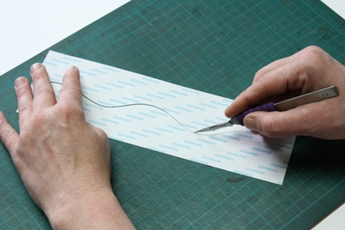

Step 2: Cut Splash cardstock (Bazzill) to 5.5 x 8.5 inches. Score at 4.25 inches and fold the card. Lay 40 MM Be Creative tape on the card front ¼ inch from the fold. Peel off backing and apply positive punched border mask to exposed tape backing. Press the mask to the tape firmly using another piece of backing to protect the exposed tape.

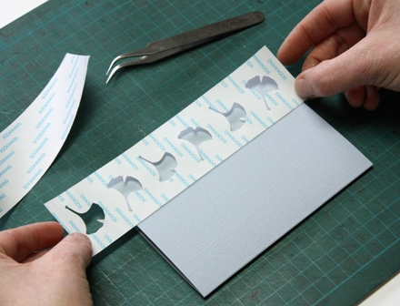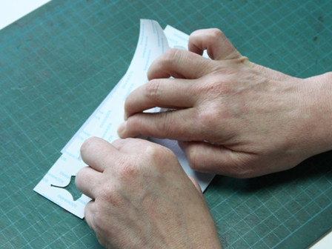

Step 3: Apply Black Microfine Glitter to the exposed tape. Brush off excess glitter.

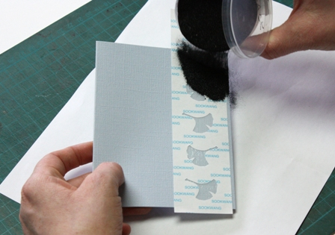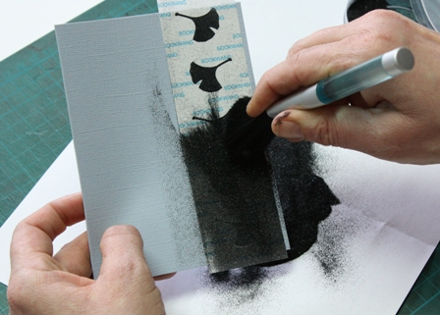

Step 4: Burnish with your fingertip by rubbing the glittered area firmly. Remove the positive border mask.

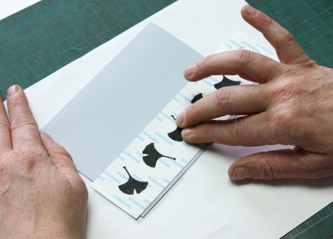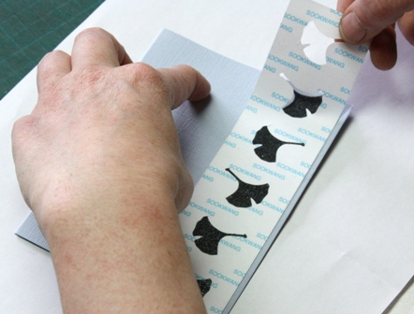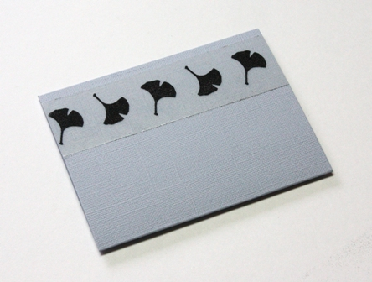

Step 5: Apply one half of the wavy border mask over the glittered leaves on the exposed tape. Apply the second half of the wavy mask to match the shape, leaving a small border of tape exposed. Press the wavy mask to the tape firmly using another piece of backing.

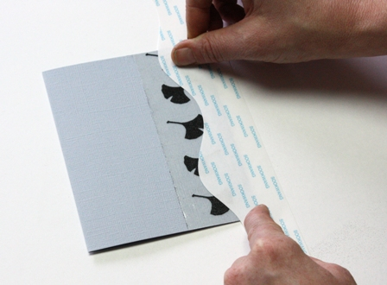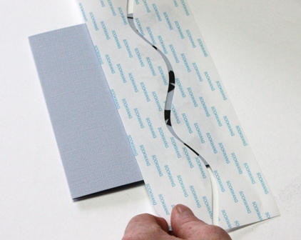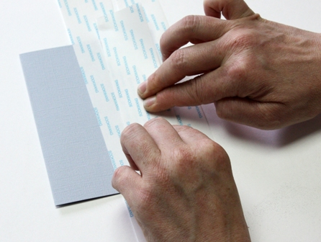

Step 6: Apply Liberty Blue Microfine Glitter to the exposed tape. Brush off excess glitter. Burnish with your fingertip by rubbing the glittered area firmly. Remove the wavy masks.

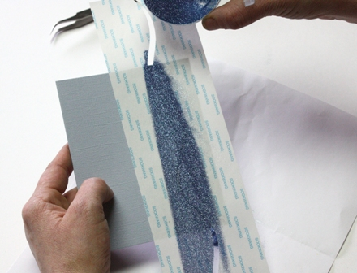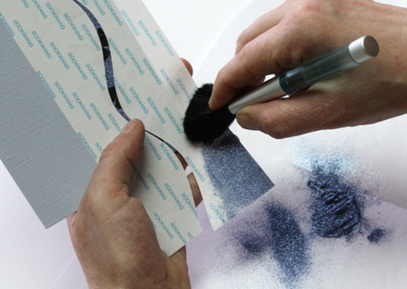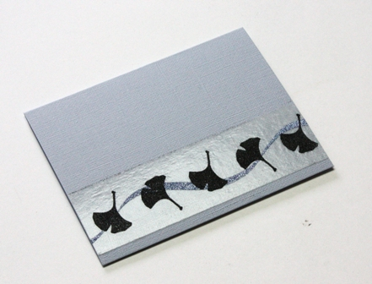

Step 7: Repeat step #5, but this time place the "waves" over a different section of the leaves.

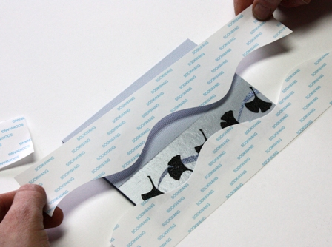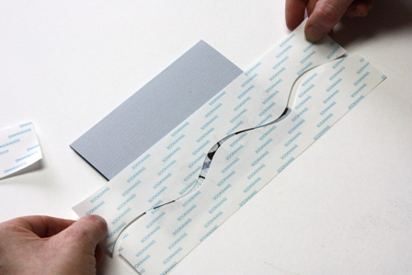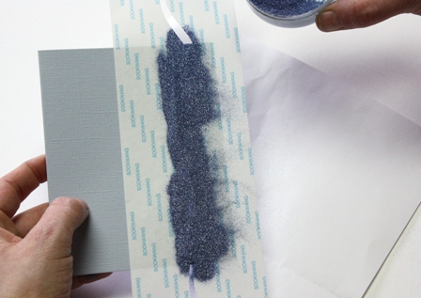

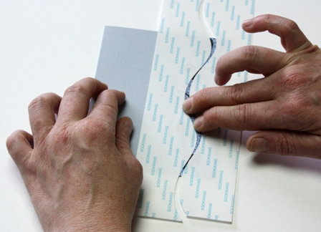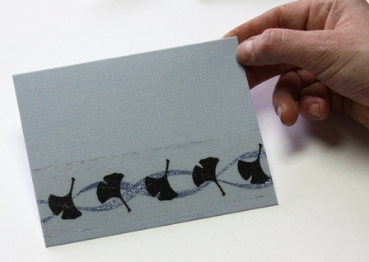

Step 8: Apply Stardust Microfine Glitter to the remaining exposed tape. Brush off excess glitter. Burnish with your fingertip by rubbing the glittered area firmly.

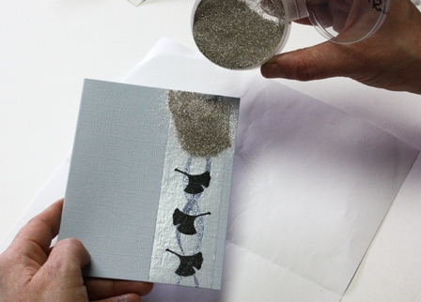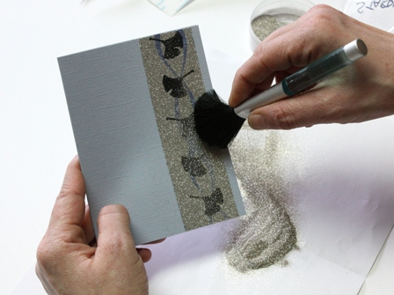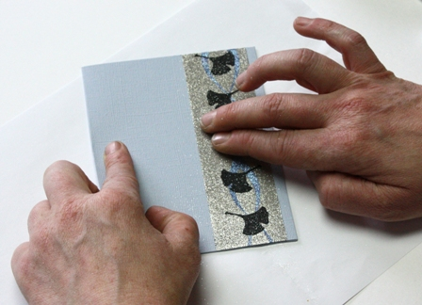

Step 9: Use Be Creative Glitter Magnet to clean excess glitter from your workspace. Note: Do not use Glitter Magnet on masks or paper.

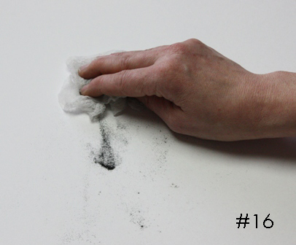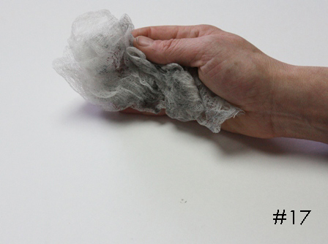

Step 10: Apply 40mm tape to black cardstock. Turn the cardstock over and trim excess edges. Trim cardstock away from the tape. Using a metal edges ruler, cut a 1/4 inch border from your tape backed cardstock - you how have a sticker! Remove tape backing with tweezers and apply a border to either side of your glittered design. Turn the card over and trim excess border.

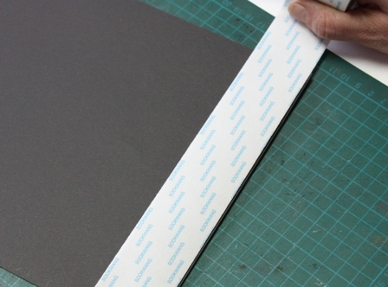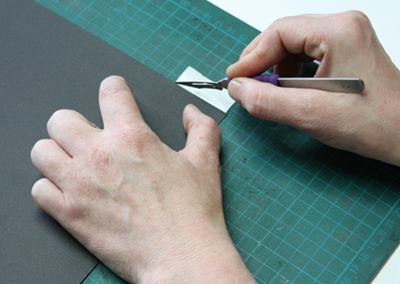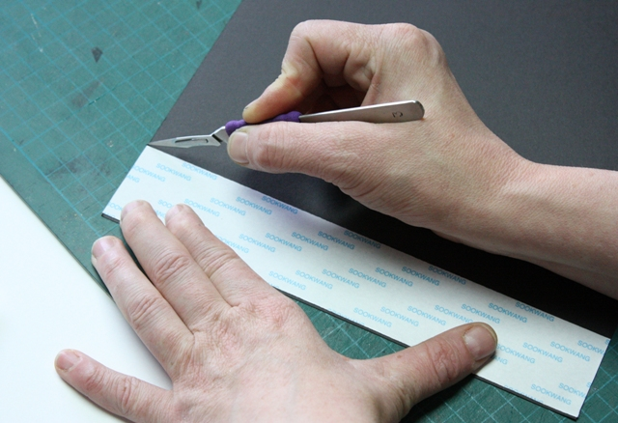
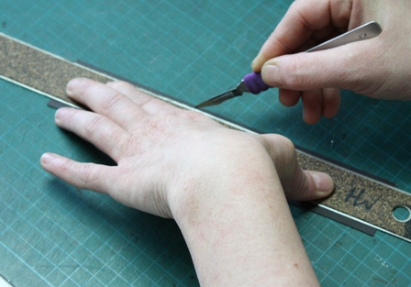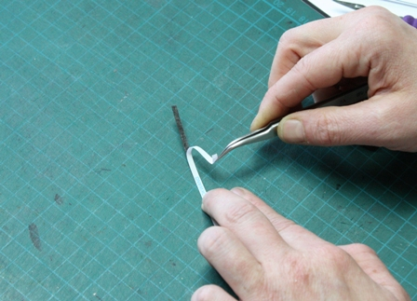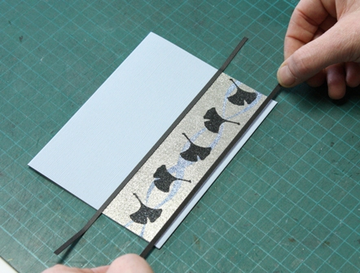

Mailing Tip: Place card inside plastic sleeve before the paper envelope to ensure your card arrives in perfect condition. The humidity in differing climates can affect the adhesive slightly.

